**FUNCTIONAL SPECIFICATIONS**

**Reservation Form Need to print**

**DOCUMENT APPROVAL**

|  |  |  |  |
| --- | --- | --- | --- |
| **Name** | **Role** | **Date** | **Remarks** |
|  |  |  |  |
|  |  |  |  |

**DOCUMENT MODIFICATION LOG**

|  |  |  |  |
| --- | --- | --- | --- |
| **Version** |  | **Date** | **Responsible** |
| 1.0 | Initial version - Functional spec | 27.12.2023 | Shrinivas |
|  |  |  |  |
|  |  |  |  |
|  |  |  |  |

**GEOGRAPHICAL SCOPE OF THE GAP**

**CORE LAYOUT**

|  |  |  |
| --- | --- | --- |
| **Country** | **Company code** | **Plant** |
| US | GMC1 | GM01 |
| US | GRCI | GR01 BR01  MU01  LK01  HR01 |

**TABLE OF CONTENTS**

1. FUNCTIONAL OVERVIEW……………………………………………………………………..4

1.1 Summary of the Gap…………………………………………………………………………4

1.2 Business requirements……………………………………………………………………...4

1.3 As-Is business process……………………………………………………………………..4

1.4 To-Be Process……………………………………………………………………………….4

1.5 Screen layout………………………………………………………………………………..4

1.5.1 Input format……………………………………………………………………….4

1.6 Suggested validation………………………………………………………………………..4

1.7 Customizing requirement…………………………………………………………………...5

1.8 Technical suggestion………………………………………………………………………..5

1. **FUNCTIONAL OVERVIEW**

**1.1 Summary of the Gap:**

.

Based on Business requirement there is no standard form available for material required qty and issue qty

In single Form. For this we need to develop Z code to get out in print out form.

**1.2 Business requirement:**

Business requirement is that to be printed in SAP S/4 HANA

**1.3 As-Is business process:**

The current business process is using manual form to get updated in required and issued quantity and get keeping in file for future reference/

**1.4 To-Be process:**

As a part of the upgrade process to SAP S/4 Hana, here we are developing a program Z code to get the print out Form.

**1.5 Input Selection screen:**

1. Reservation Number : (RESB-RESNUM) - Mandatory

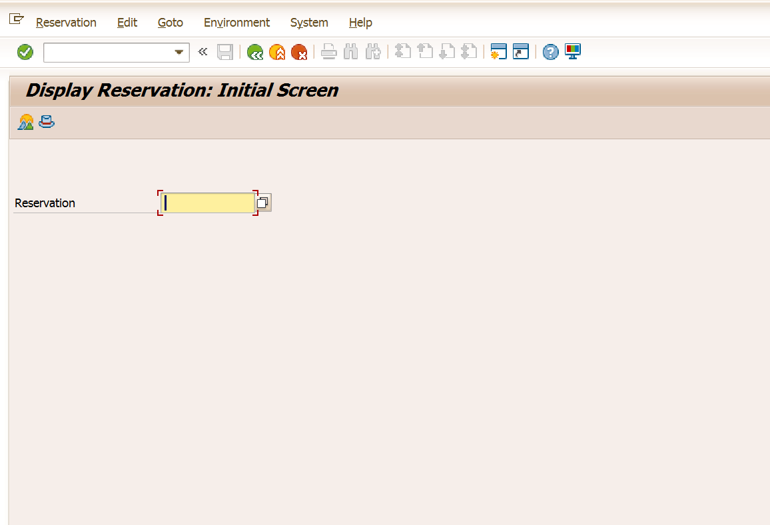

**1.6** **Suggested Validation**

* Check weather the uploaded file is excel file (.xls or .xlsx)
* If the excel is empty - “Uploaded excel is empty” - type error ‘E’. on the selection screen or in a pop up window in the selection screen.
* Uploaded data plant to be relevant to the plant on the selection screen.

For validating the forecast input received in the excel format.

* Material - Check MARC-MATNR
* Plant - Check MARC-WERKS
* Version - to be always in “00”
* Version - should always be active version ‘X’
* Requirement no. - to be numeral and no decimals allowed
* Date type - 1/2/3 (1-daily, 2-Weekly, 3- Monthly)
* Requirement date -MM.YYYY (01<MM<12, current year <= YYYY<9999)
* Quantity - 01 to 9999999. And no negative values and decimals allowed.

**1.7 Customizing requirement:**

Need a customized T-Code as ZMB21 for Reservation list after running the need to get reservation.

.

[**Required**](https://docs.google.com/spreadsheets/d/1lMwU-_cqVDGfjdFhIk8wIfPsHQHpj6GCKMbmchLBMpY/edit#gid=0) **Output Format**

|  |  |  |  |  |  |  |
| --- | --- | --- | --- | --- | --- | --- |
| **Reservation Form** | | | | | | |
|  | | Reservation Number |  | Plant |  | |
|
| Storage Location |  | |
|
| Item No/S No.. | Material | Material Description | BUN( Base Unit of Measure) | Required Quantity | Issued Quantity | Remarks |
|  |  |  |  |  |  |  |
|  |  |  |  |  |  |  |
|  |  |  |  |  |  |  |
|  |  |  |  |  |  |  |
|  |  |  |  |  |  |  |
|  |  |  |  |  |  |  |
|  |  |  |  |  |  |  |
| Issued By Store Incharge | | | Received By  Production Sepervisor | Posted By  Store Incharger | | |
|
|
|

**1.7.1. Requirement flow**

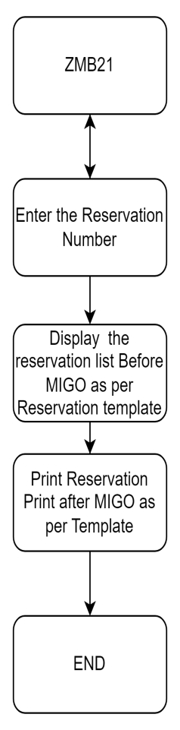

**1.8 Technical suggestion:**

For creating Z code here with below logic need to create output form.

|  |  |  |
| --- | --- | --- |
| S No. | Requirement | Technical Logic |
| 1 | Plant | Pass RSNUM in the RESB table and get the WERKS |
| 2 | Storage Location | Pass RSNUM in the RESB table and get the LGORT |
| 3 | Item No. | Pass RSNUM in the RESB table and get the RSPOS |
| 4 | Material | Pass RSNUM in the RESB table and get the MTNR |
| 5 | Material Description | Pass RSNUM in the RESB table and get the MTNR |
| Pass MATNR in the table MAKT and get MAKTX |
| 6 | BUN | Pass RSNUM in the RESB table and get the MEINS |
| 7 | Required Quantity | Pass RSNUM in the RESB table and get the BDMNG |
| 8 | Issued/Withdrawn Quantity | Pass RSNUM in the RESB table and get the ENMNG |
| 9 | Remarks/Text | Pass RSNUM in the MSEG table and get SGTXG |

**For Technical support herewith attached Logic sheet**